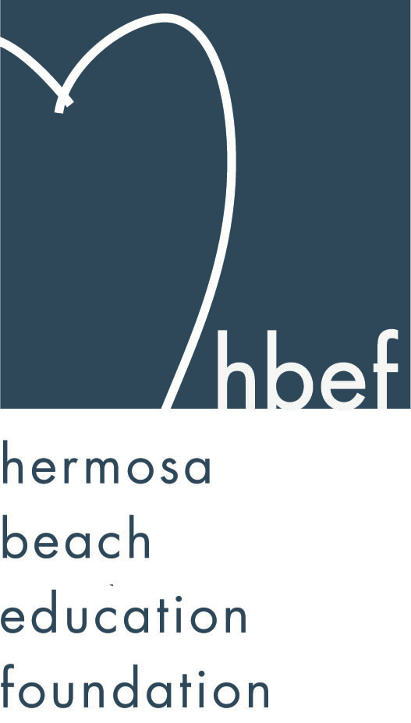Hermosa Beach Education Foundation
Board Meeting Minutes
Tuesday, May 10, 2016

Board of Directors Attendees:
Ali Malone Carla Persell Cristina Kabealo Dan Inskeep
Emily Hegenberger Patrick Goshtigian Brian Ledermann Laurie Baker
Debra Luckey Jennifer Fix Tiffany Soporito Nichole Downes
Nicole Perez Lynn Barr Howard Maycon Brian Parker
Jen Molod Courtney O’Connor Christine Tasto
Tiffani Miller Cindy Butler Lisa Searer
Louisa Cushman

Board Directors Not Present:
Kelly Trudgen Doug Gneiser Heather Harris Gail Laskowski
Monique Vranesh Lorraine Maycon Karen Buchhagen Alissa Miller
Barbara Gunning Donna Gin Zipporah Kiger Missy Wuertz
Kelly DeBeer

Honorary Board of Directors Present:
David Hart Sylvia Gluck Kim Taylor Carrie Anne Blevins
Cathy Barrow Adam Genovese Patty Ackerman
Guests:
James Scott

Call to Order
Meeting called to order, in the Valley Multipurpose Room, by Ali Malone at 7:34pm. HVPTO meeting was held as well. See HVPTO meeting minutes for detailed HVPTO information.

Flag Salute
Was led by Maggie Curtis

Presentation of Donations

Approval of Minutes
Cristina presented the minutes from the March 8, 2016 HBEF Board Meeting. Lisa Searer moved to approve the minutes and Jenny Fix seconded the motion. Motion carried by voice vote.

Executive Board Reports
Ali Malone, President
Will be stepping down as HBEF President and announced Carla Persell as the new incoming President for 2016/17 school year. Voting will take place in our June Meeting. Next Board Meeting is scheduled for June 7th but because that is voting day, we will change the date and notify everyone when we figure out a date.

Brian Ledermann & Alissa Miller (Shadow) Operations - Policy and Procedures
Alissa Miller was not in attendance.
Brian had nothing to report for operations. Asking for volunteers for the Beer Garden during Fiesta Hermosa for Memorial Weekend.

Cristina Kabealo, Secretary
Cristina had nothing to report.

Dan Inskeep, Treasurer
Presented the Profit & Loss Report and the Balance Sheet Report. Reduced our expenses by 13% from last year. (report provided).

Patrick Goshtigian, CIO Investments
Presented the Allocation Report. Our ending market value – April 30, 2016 is $1,693,852 (report provided).

Gail Laskowski and Lisa Searer, Annual Appeal
Gail Laskowski was not in attendance.
Annual Appeal is behind $100K. We currently raised $351K for the year. We are behind in matching because of the new procedures with companies. 2nd grade class has the highest percentage with Annual Appeal donations. Surfboards are up at Valley. Will continue to push Annual Appeal through June.

Lynn Barr, Fundraising
HOH was a huge success and thanked the team for all there hard work. Sk8 for School raised over $7K at the April 29th event thanks to the Kuhr Family.

Jen Molod, Sponsorships
Taking it easy with sponsorhip till next school year.

Laurie Baker & Christine Tasto (Shadow) Public Relations
We now have 728 Facebook Friends. Will continue to push Annual Appeal in Newsletters and social media.

Board Action

Activities Completed for 2015-2016
Back to School Picnic – September 11, 2015
Fall Mixer – September 23, 2015
Wine Walk – October 10, 2015
Skechers Pier to Pier Walk – October 25, 2015
Gumtree Santa Photos – November 22 & 29, 2016
Mom’s Night Out – January 27, 2016
Hearts of Hermosa – March 19, 2016

Other Reports
PTO, Jenny Fix/Louisa Cushman
Looking for people to fill some open positions with PTO, accepting nominations and voting will take place in the June meeting. They will also announce the new PTO President for 2016/17 school year. June meeting is very important with attendance – need a quorum to vote on PTO funds. Father/Daughter Dance was the most recent event and it raised $6606.00. Budget report was presented. Yearbooks are available online till May 15th. On the last week of school, boxes will be provided at both Valley and View for used school supplies and will donate to Lenox School. Looking for volunteers for Memorial Day Parking lot – Saturday shifts are still available, 4th Grade Field Day, Book Fair for both Valley and View. Mother/Son Bowling sold out on the first day – PTO is trying to figure out a new event that can accommodate all boys and moms for next school year. Teacher Grants – forms needs to be filled out and turned in by July in order for it to get processed by Sept. School Supplies are available online for Kinder-5th grade.

Superintendent, Pat Escalante
Pat Escalante was not in attendance.

School Board Representative, Patty Ackerman
Thanked the board for all we do. Her daughter is in 8th grade – this is it for the AcKerman’s. There is a school board meeting tomorrow night where they will disclose reports on traffic study and will be talking all about Measure S. There will be two meetings in June (dates to come).

View and Valley Principals, Sylvia Gluck (View) and Kim Taylor (Valley)
Sylvia thanked PTO on behalf of View School for SAW. Kinder-3rd are working on writers workshop. 3rd grade will be visiting Valley School on June 4th. The last box top contest just started.
Kim thanked PTO for SAW. Valley is completing Smarter Balance Testing and it is going well. The Middle School 1st Annual Movie Night was a success and plan to have many more movie nights. The 8th grade Promotion Ceremony will be on June 17th followed by at dance at 8pm-10pm. Currently working on next school years calendar. May 24th is the last Parent Ed Night “Sex, Drugs and Rock N Roll” – what to expect with a high schooler. May 31st is 5th grade Parent Night – what to expect in middle school. June 9th is valley Open House at 6:30pm – YAA will have the annual art show before. Thanked Mr. Genovese for all his work since joining HBSD. New video coming soon.

View Teacher Representative, Gia Busse (K-3rd)
Gia Busse was not in attendance.

Valley Teacher Representatives, David Hart (4th & 5th) and Cathy Barrow (6th-8th)
Mr. Hart thanked PTO for SAW and passed around the thank you cards signed by Valley staff. 4th grade – June 6th will take a field trip to The Grammy Museum, June 8th is Gold Rush Day, June 15th will be the Science Fair in MPR and June 16th is Field Day (pending parent volunteer to chair the event). 5th grade - is midway with Walk Through Revolution, May 20th is Puberty Video Day, May 25th will be field trip day at the Griffith Observarory, June 7th is the Grammy Museum field trip and June 16th is Beach Day for all 5th graders.

Ms. Barrow thanked PTO for SAW on behalf of all middle school staff. 8th graders will give the 3rd graders there books when they visit on June 4th for the school tour.

Roundtable/Questions/Guests
Carrie Anne Blevins (BCHD) – Thanked Carla Persell for her amazing job in running the Nutrition Program. Thinking about starting a Garden Lesson at View for the upcoming school year. BCHD is looking for a new CEO – current CEO is retiring. There will be a Mind Up Training for all teachers in June. Celebrated this evening at Mediteraneo Restaurant in HB that we are officially a Certified Blue Zone Community. May 21st is Walk About Redondo and it is a family event from 10am-3pm. Every Monday in June starting June 6th is free fitness – yoga in MB. July will be Zumba Mondays. Adventureplex Camp is available and space is limited so book now.

James Scott – Yes on Measure S and is asking for everyone’s support. Talk to your neighbors, come to the meetings and vote on June 7th.

Calendar
Upcoming 2016-17 HBEF Events (DATES ARE SUBJECT TO CHANGE)
September 28, 2016 – Fall Cocktail (Goshtigian Home) 7-9pm
October 15, 2016 – 5th Annual Hermosa Wine Walk (Power St.) 5:30-9:30pm
October 23, 2016 – Skechers Pier to Pier Walk
November 27, 2016 – Santa Photos (Gumtree) 10am-4pm
December 04, 2016 – Santa Photos (Gumtree) 10am-4pm
January 25, 2017 – Mom’s Night Out (Comedy & Magic Club)
March 18, 2017 – Hearts of Hermosa
April 3rd-7th, 2017 – Annual Appeal Pledge Week

Upcoming 2015-16 HBEF Meetings
June 14, 2016 – 7:30pm in Valley MPR

Adjournment
Ali Malone adjourned the meeting at 8:30pm.

Respectfully submitted by Cristina Kabealo

