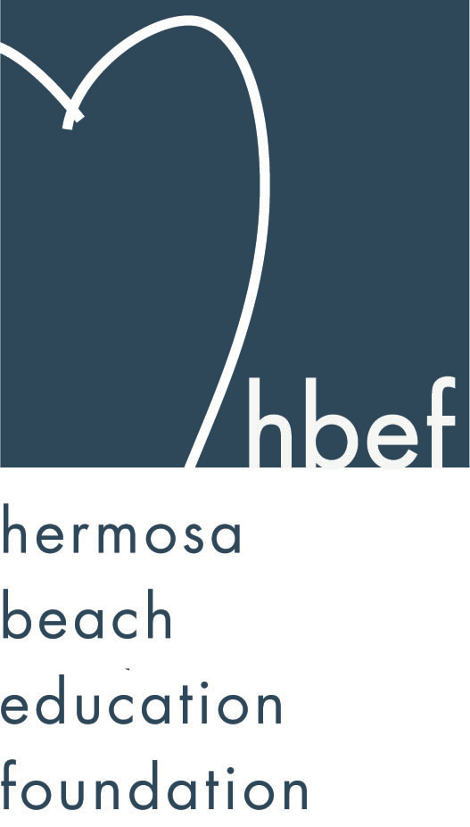Hermosa Beach Education Foundation
Board Meeting Minutes
Tuesday, March 8, 2016

Board of Directors Attendees:
Ali Malone Alissa Miller Carla Persell Cristina Kabealo Dan Inskeep Emily Hegenberger Patrick Goshtigian Brian Ledermann
Debra Luckey Donna Gin Gail Laskowski Jennifer Fix
Nicole Perez Lynn Barr Howard Maycon
Jen Molod Monique Vranesh Courtney O’Connor Kelly DeBeer
Tiffani Miller Cindy Butler Lisa Searer Zipporah Kiger
Missy Wuertz Louisa Cushman

Board Directors Not Present:
Kelly Trudgen Doug Gneiser Heather Harris Laurie Baker
Tiffany Soporito Nichole Downes Christine Tasto
Barbara Gunning Brian Parker
Lorraine Maycon Karen Buchhagen

Honorary Board of Directors Present:
David Hart Gia Busse Kim Taylor Carrie Anne Blevins
Cathy Barrow

Guests:
Nadine Bryker Maggie Bore-LaMonica

Call to Order
Meeting called to order, in the Valley Multipurpose Room, by Ali Malone at 7:33pm. HVPTO meeting was held as well. See HVPTO meeting minutes for detailed HVPTO information.

Flag Salute
Was led by Madie “Noodle” Malone

Presentation of Donations

Approval of Minutes
Cristina presented the minutes from the January 12, 2016 HBEF Board meeting. Lynn Barr moved to approve the minutes and Cindy Butler seconded the motion. Motion carried by voice vote.

Executive Board Reports

Ali Malone, President
Skechers check presentation is this Thursday evening. Buy you Hearts tickets now!
Donna/Monique – we had 1100 walkers and made 130K in Skechers Walk. Looking for shadows to take over Skechers Walk, will happily stay on to help the new chairs next year.

Brian Ledermann & Alisa Miller (Shadow) Operations - Policy and Procedures
Brian and Alissa had nothing to report.

Cristina Kabealo, Secretary
Cristina had nothing to report.

Dan Inskeep, Treasurer
Shared Profit and Loss Statement and Balance Sheet as of March 7, 2016 (report provided). A lot of companies that match are using 3rd party administrator which is slowing down funds from coming in. We are tracking pretty close and current total does not include Skechers Walk.

Patrick Goshtigian, CIO Investments
Sticking to the allocations (report provided).

Gail Laskowski and Lisa Searer, Annual Appeal
Annual Appeal big push will start April 2nd. We are behind from last year but confident we will be back on track with every board members support during pledge week April 18th – 23rd tables will be set up at both schools. Working with PR for better messaging to get everyone donating.

Lynn Barr, Fundraising
MNO was a huge success thanks to Jenny Fix and her team. We raised 10K that night. HOH is coming up, still looking for registration volunteers and late night crew for clean up after event. Will create an online sign up so PTO can help spread the word to all room parents.

Jen Molod, Sponsorships
As of tonight we have 146K in Sponsorship. Seats are still available for Hearts at $1500.00 for 2 seats. Banner is up on Pier Ave. PR has been sending out weekly Newsletters and FB postings highlighting our Sponsors.

Laurie Baker & Christine Tasto (Shadow) Public Relations
Laurie and Christine was not in attendance.
Ali reported – we have 702 FB Friends and 177 Instagram Friends. After Hearts PR will be pushing Annual Appeal.

Board Action

Activities Completed for 2015-2016
Back to School Picnic – September 11, 2015
Fall Mixer – September 23, 2015
Wine Walk – October 10, 2015
Skechers Pier to Pier Walk – October 25, 2015
Gumtree Santa Photos – November 22 & 29, 2016
Mom’s Night Out – January 27, 2016

Other Reports
PTO, Jenny Fix/Louisa Cushman
Looking for people to fill some open positions with PTO. Volunteer Talk with coffee and bagels will be held on April 20th at View. Read Across America was a huge success. First year taking over teacher grants and it is doing great. Teachers from both Valley and View in every grade put a request in and everything was approved. PTO raised 140K this year (report attached). 3,000 books were donated to a clinic in Long Beach. Field Day at Valley will be on June 16th – need volunteers. Father/Daughter Dance will be April 22nd – Save The Date announcement is coming soon. SAW will be the week of May 2nd – 6th.

Superintendent, Pat Escalante
Little league is growing and running out of space – District is thinking of a partnership and will be voting tomorrow on an agreement. Asking parents to let her know anytime there is a kid event because she wants to attend all of them. District is going out with another bond in June and a series of informational meetings will be coming up. The music grant through LA25 is awesome, next concert is March 14th at 1pm – encouraging parents to attend. Working with HBYM to figure out how to bring music back to our schools and HBYM will be giving a proposal tomorrow night. Kinder registration has declined due to half day schedule however, the Star Program has soared. Received 25K from Chevron who is a greater supporter of our schools and part of that money will continue to fund Idea Lab.

School Board Representative, Mary Campbell
Mary was not in attendance.
Maggie Bore La Monica – encouraging parents to talk to our neighbors about our schools - our facilities are in dire need!

View and Valley Principals, Sylvia Gluck (View) and Kim Taylor (Valley)
Ms. Gluck was not in attendance.
Pat reported that View is up for the Blue Ribbon Award this Friday and Sylvia is working very hard to make the school even more presentable.
Kim Taylor – Congrats to our Science Olympiads. Middle School Dance this Friday and it is a country western theme. A rep from Honda came last week and brought a hydrogen car for our 8th grade class to study, view and learn about. 6th graders are heading to Malibu this coming Monday. 3rd – 8th grade teachers are gearing up for state testing which will happen after Spring Break. 8th grade class is already registering for high school. Encouraging parents to come to her monthly coffee talks and another staff video is in the works.

View Teacher Representative, Gia Busse (K-3)
Dolphin Dash was a huge success thanks to the many parent volunteers. Read Across America was amazing. 3rd grade standardized testing will happen in April.

Valley Teacher Representatives, Cathy Barrow (6-8) and David Hart (4-5)
Mr. Hart – the books are a big hit in the 4th and 5th grade writers workshop. Colonial Day is coming up for 5th graders on March 30th and it is an all day event. The 5th grade Puberty Video will be shown in May. Teachers from both Valley and View went to a 3 day Tech training class.
Ms. Barrow – 8th grade students are getting ready to write the 3rd grade story books. The celebration will be on the same day the 3rd grade students take a field trip tour of Valley.

Roundtable/Questions/Guests
BCHD – Carrie Anne Blevins – ribbon cutting for View Garden was beautiful. Kinder thru 5th grade Nutrition Lessons is doing well. March 15th 5:30pm – 6:30pm is Parent Ed Night – “Mindfully Connecting At The Dinner Table”. Kids are welcomed. There will be a Walking School Bus audit coming up. This is to make sure all is good with the program. Carrie will be attending the Blue Ribbon Ceremony at View to show her support for Sylvia.

Calendar
Upcoming 2015-16 HBEF Events
March 19, 2016 – Hearts of Hermosa
April 11-15, 2016 – Annual Appeal Pledge Week

Upcoming 2015-16 HBEF Meetings
May 10, 2016 – 7:30pm in Valley MPR
June 7, 2016 – 7:30pm in Valley MPR

Adjournment
Ali Malone adjourned the meeting at 8:45pm.

Respectfully submitted by Cristina Kabealo

