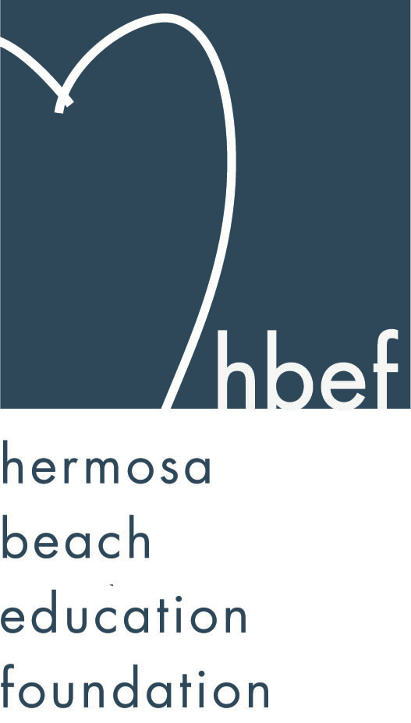Hermosa Beach Education Foundation
Board Meeting Minutes
Tuesday, January 12, 2016

Board of Directors Attendees:
Ali Malone Alissa Miller Carla Persell Doug Gneiser
Cristina Kabealo Dan Inskeep Emily Hegenberger Patrick Goshtigian
Debra Luckey Donna Gin Gail Laskowski Heather Harris
Nicole Perez Laurie Baker Lynn Barr Howard Maycon
Jen Molod Monique Vranesh Courtney O’Connor Kelly DeBeer
Tiffany Soporito Tiffani Miller Kelly Trudgen Cindy Butler
Louisa Cushman Nichole Downes Christine Tasto

Board Directors Not Present:
Brian Ledermann Barbara Gunning Brian Parker Jennifer Fix
Lorraine Maycon Karen Buchhagen Lisa Searer Zipporah Kiger
Missy Wuertz

Honorary Board of Directors Present:
Adam Genovese Gia Busse Sylvia Gluck Carrie Anne Blevins

Guests:
Steve Urich Sandy Fineman Sandra Yokoo Jill McCurry
Patti Ackerman Maggie Bore-CaMonica

Call to Order
Meeting called to order, in the Valley Multipurpose Room, by Ali Malone at 7:31pm. HVPTO meeting was held as well. See HVPTO meeting minutes for detailed HVPTO information.

Flag Salute
Was led by Kelly Trudgen

Presentation of Donations

Approval of Minutes
Cristina presented the minutes from the June 16, 2015 HBEF Board meeting. Cindy Butler moved to approve the minutes and Alissa Miller seconded the motion. Motion carried by voice vote.

Executive Board Reports

Ali Malone, President
Announced that her term for President is up this June and is looking for the next leader. Will stay on the board to help guide the new President with his/her duties.

Brian Ledermann & Alisa Miller (Shadow) Operations - Policy and Procedures
Brian was not in attendance. Alissa had nothing to report

Cristina Kabealo, Secretary
Working on Hearts Silent Auction and asked for donations. Passed around the sign in sheet.

Dan Inskeep, Treasurer
Shared Profit and Loss Statement and Balance Sheet for July 1 through January 10, 2016. (report provided). Announced that One West Bank will be on a trial basis for a few months to see if it fits the criteria we are looking for.

Patrick Goshtigian, CIO Investments
HBEF funds are fully invested.

Gail Laskowski and Lisa Searer, Annual Appeal
Lisa was not in attendance. As of today Annual Appeal is at $72,000. Posted wave signs at View School to show who has already donated and give awareness to the parents. Lawn signs are coming back up. Looking for volunteers to help with Annual Appeal. Putting together a mailer that will show the purpose of HBEF and will reach out to our community.

Lynn Barr, Fundraising
Gum Tree santa Photos was a huge success and made over $8,600. Moms Night Out is sold out. Working of HoH and looking for helpers. Tons of positions are available to be filled to make the event a huge success.

Jen Molod, Sponsorships
Sponsorship has already sol $50,000. Looking for help with contacting people to get with the deadline for HoH cut-off. Asking for connections as well.

Laurie Baker & Christine Tasto (Shadow) Public Relations
Getting ready to promote HoH. Next HBEF Happenings will be next week. We have 687 Facebook Friends.

Board Action

Activities Completed for 2015-2016
Back to School Picnic – September 11, 2015
Fall Mixer – September 23, 2015
Wine Walk – October 10, 2015
Skechers Pier to Pier Walk – October 25, 2015
Gumtree Santa Photos – November 22 & 29, 2016

Other Reports
PTO, Jenny Fix/Louisa Cushman
Jenny was not in attendance. Dolphin Dash at View is on Feb. 5th – asking for volunteers to help run the event. Flyers will be out this week. Halloween Carnival made $42,000. Spirit Wear Table will be set up at View this week. Read Across America and Book Drive is coming up on March 4th. 705lbs of candy were donated along with 125 letters to the troops. PTO so far has funded $34,000. in grants this year (report provided). PTO has taken over Teacher Grants and recently purchased six new microscopes for Valley School. Re-allocated $2,000. to buy new playground equipment for View School. To date a lot of grants have been fulfilled.

Superintendent, Pat Escalante
Pat was not in attendance.

School Board Representative, Mary Campbell
Mary was not in attendance.

View and Valley Principals, Sylvia Gluck (View) and Kim Taylor (Valley)
Ms. Taylor was not in attendance. Sylvia is encouraging parents to come to the Envisioning Workshop on Jan. 24th. Also happening on Jan. 24th – New Kinder Orientation. Half day Kinder will continue for the following school year. Working with PTO on Organizing the upcoming 2nd Annual Dolphin Dash. Next Coffee Talk will be this Thursday at 8:45am. Thanked BCHD and Dr. Gross Memorial Fund for the grant received for The Garden Club. They now have new garden beds. Coat drive was a huge success thanks to the hard work of the Girl Scout Troops.

Valley Assistant Principal, Adam Genovese
Encouraging all parents to attend Parent Night on Jan. 26th at 5:30pm in Valley MPR. Presented the board with the new staff video for our students.

View Teacher Representative, Gia Busse, Malinda Gill (K-3)
Malinda Gill was not in attendance. Kinders are working hard in Writers Workshop. 100 days of school is coming up. 3rd Grade class is gearing up for testing. Thanked PTO for all the new equipment at View. Lots going on but all are great.

Valley Teacher Representatives, Cathy Barrow (6-8) and David Hart (4-5)
David & Cathy were not in attendance. Adam reported for both. Adopt A Family was a huge success thanks to Ms. Vizzi organizing the program. 4th Grade Class just finished Walk Through California. 5th Grade Class will be doing Walk Through Revolution. Lip Sinc Concert was a hit with a surprise performance from the 5th Grade Teachers. 7th Grade class is in Catalina this week and is having a great time. Focusing on the 8th Grade class and helping them transition to high school next year.

Roundtable/Questions/Guests
BCHD – Carrie Anne Blevins – Dr. Gross Memorial Fund donated to View School Garden Club from his recent passing. Live Well will be training nutrition docents in Feb. BCHD Gym is offering HVS Staff a discount to join the gym. Jan. 27th is the Walk To School promotion day. CEO of BCHD will attend Read Across America at View and read to the students. Adventureplex has a new toddler area located in the 2nd floor of the building.

View Garden Rep – Sandra Yokoo – Thanked BCHD for the donation of new garden beds. Asking for volunteers to help with the garden at View.

Calendar
Upcoming 2015-16 HBEF Events
January 27, 2015 - Mom’s Night Out at The Comedy and Magic Club
March 19, 2016 – Hearts of Hermosa
April 11-15, 2016 – Annual Appeal Pledge Week

Upcoming 2015-16 HBEF Meetings
March 8, 2016 – 7:30pm in Valley MPR
May 10, 2016 – 7:30pm in Valley MPR
June 7, 2016 – 7:30pm in Valley MPR

Adjournment
Ali Malone adjourned the meeting at 8:33pm.

Respectfully submitted by Cristina Kabealo

