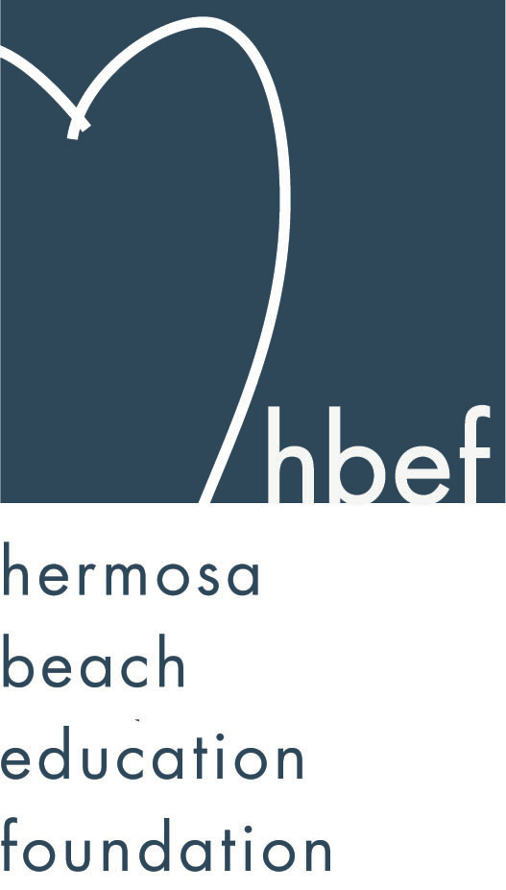Hermosa Beach Education Foundation
Board Meeting Minutes
Tuesday, September 22, 2015

Board of Directors Attendees:
Ali Malone Brian Ledermann Christine Tasto Doug Gneiser
Carla Persell Cristina Kabealo Dan Inskeep Emily Hegenberger
Debra Luckey Donna Gin Gail Laskowski Heather Harris
Alisa Miller Laurie Baker Lynn Barr Jenny Fix
Maggie Curtis Monique Vranesh Courtney O’Connor Kelly DeBeer
Patrick Goshtigian Tiffani Miller Zipporah Kiger Kelly Trudgen
Lisa Searer Louisa Cushman Missy Wuertz Nichole Downes
Zipporah Kiger

Board Directors Not Present:
Barbara Gunning Brian Parker Cindy Butler Howard Maycon
Jen Molod Lorraine Maycon Karen Buchhagen Nicole Perez
Tiffany Soporito

Honorary Board of Directors Present:
Cathy Barrow Kim Taylor Pat Escalante Malinda Gill

Guests:
Adam Genovese Andrea Marriott Christine Schultz Bill Miller
David from LA25 Lisa Vargas Gardner

Call to Order
Meeting called to order, in the Valley Multipurpose Room, by Ali Malone at 7:35pm. HVPTO meeting was held as well. See HVPTO meeting minutes for detailed HVPTO information.

Flag Salute
Was led by Jack Searer

Presentation of Donations
Dan Inskeep presented an $800.00 check for recycling bottles and cans – the CRV check will go in the endowment funds.

Approval of Minutes
Cristina presented the minutes from the June 16, 2015 HBEF Board meeting. Lisa Searer moved to approve the minutes and Dan Inskeep seconded the motion. Motion carried by voice vote.

Executive Board Reports

Ali Malone, President
Updated everyone on the Summer Retreat. Shared upcoming dates and events for HBEF.

Brian Ledermann & Alisa Miller (Shadow) Operations - Policy and Procedures
Passed around The Confidentiality Report for those who have not signed a current one.

Cristina Kabealo, Secretary
The 2015-16 Sign In Sheet was passed around for verifying and signature

Dan Inskeep, Treasurer
Shared Profit and Loss Statement and Balance Sheet for July 1 through September 4, 2015. (report provided).

Patrick Goshtigian, CIO Investments
Shared Portfolio Asset Allocation as of August 31, 2015 (reports attached).

Gail Laskowski and Lisa Searer, Annual Appeal
Plan to do a big push for Annual Appeal. Nov. 2nd will be the start of the Grandparents Program. Dec. 1st is National Giving Tuesday – the perfect day to promote Annual Appeal.

Lynn Barr, Fundraising
Back To School Picnic was a huge success. Fall Mixer is coming up Sept. 30th, 2015 and encouraged everyone to spread the word and to pass out some flyers. Gumtree, Of the Hook and CPK will donate food for the event. Wine Walk Tickets – 195 sold as of 4:30pm on 09/22/15. Skechers Walk - goal is 1200 walkers this year and hoping to raise $100K – Donna Gin and Monique Vranesh will send updates when it’s ready.

Jen Molod, Sponsorships
Was not in attendance. But sponsorship is going great, Jen is working very hard per Ali Malone. Big push will be done closer to Hearts of Hermosa.

Laurie Baker & Christine Tasto (Shadow) Public Relations
Introduced her shadow Christine Tasto who will be taking over in the 2016-17 school year. Working on HBEF being a source of information rather than a place that always ask for money. Facebook count as of 09/22/15 is at 632.

Board Action

Activities Completed for 2015-2016
Back to School Picnic – September 11, 2015

Other Reports
PTO, Jenny Fix/Louisa Cushman
Had a Thank You Event for all volunteers at the Ocean Bar over the summer. Announce that there will no longer be Room Moms for all middle school grades and instead will put all donation $$ together to take care of all middle school staff for all events. Missy Wuertz will donate a portion of her profits by taking pictures during the 8th grade graduation. Box Tops contest is going on now. Will not push e-scrip due to Vons no longer participating and the local Ralphs has closed but will look into the Benefit App for future e-scrip Program.

Superintendent, Pat Escalante
Third year in a row of moving kids around to accommodate all the kids in both schools. The 3rd Grade team is now back at View School. The transition went well. The district spent over $1 million to make changes for our overcrowding schools and although seems like a lot of money it was well worth the changes. Need to go the the state to get approval for another 3 years on older portables. Envisioning workshop was held on 09/21/15 – they talked about the parking, size of the bond and Pat is encouraging parents to please attend future workshops to get our voices heard. Heroes Group have a strong communication with our community. Refrain from using wine bottles on any event flyers at school.

School Board Representative, Mary Campbell/Lisa Claypoole
Was not in attendance.

View and Valley Principals, Sylvia Gluck (View) and Kim Taylor (Valley)
Ms. Gluck was not in attendance – per Kim 3rd grade transition went well.
Mrs. Taylor introduced Valley’s new Assistant Principal Mr. Genovese. Went to the first YAA Workshop at American Martyrs to thank the volunteer parents for their time. Safe Ambassador Program is asking for parent volunteers to help with the 2 day seminar on Oct. 1st and 2nd talk to Christy Cole for more info. Meet and Greet will start soon. Follow valley on Twitter – they will do a post daily.

View Teacher Representative, Gia Busse, Malinda Gill (K-3)
Gia Busse was not in attendance.
Ms. Gill will be co-representative for View (K-3). Thanked PTO for the Welcome Back Luncheon and Gift Cards. She went to the first CGI Meeting.

Valley Teacher Representatives, Cathy Barrow (6-8) and David Hart (4-5)
David was not in attendance.
Ms. Barrow – 8th Graders are gearing up for Astro Camp (Oct. 7th – Oct. 9th).

Roundtable/Questions/Guests
David from LA25 spoke about the event. Proceeds will benefit HBEF. Go to
Art310.org for more info

Adam Genovese (Assistant Principal for Valley) is working on a staff video to share with the kids. This will help break the wall between teacher and kids.

Calendar
Upcoming 2015-16 HBEF Events
September 23, 2015 - HBEF Fall Mixer
October 10, 2015 – HBEF Wine Walk
October 25, 2015 – Skecher’s Pier To Pier Walk
November 22 & 29, 2015 - Santa Photos at gum tree 10am-4pm
January 2016 - TBD - Mom’s Night Out at The Comedy and Magic Club
March 19, 2016 – Hearts of Hermosa
April 11-15, 2016 – Annual Appeal Pledge Week

Upcoming 2015-16 HBEF Meetings
November 10, 2015 – 7:30pm in Valley MPR
January 12, 2016 – 7:30pm in Valley MPR
March 8, 2016 – 7:30pm in Valley MPR
May 10, 2016 – 7:30pm in Valley MPR
June 7, 2016 – 7:30pm in Valley MPR

Adjournment
Ali Malone adjourned the meeting at 8:35pm.

Respectfully submitted by Cristina Kabealo

