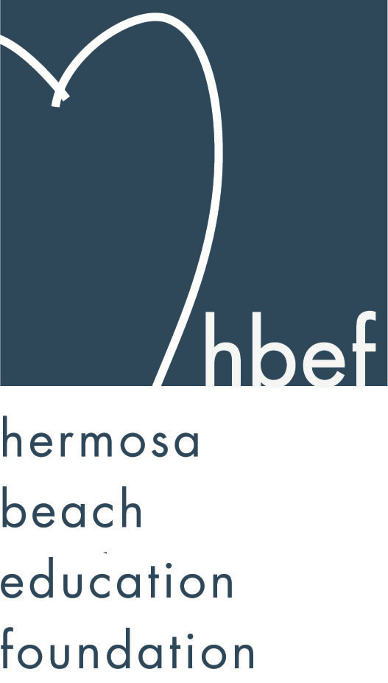Hermosa Beach Education Foundation
Board Meeting Minutes
Tuesday, November 10, 2015

Board of Directors Attendees:
Ali Malone Brian Ledermann Christine Tasto Doug Gneiser
Carla Persell Cristina Kabealo Dan Inskeep Emily Hegenberger
Debra Luckey Donna Gin Gail Laskowski Heather Harris
Alisa Miller Laurie Baker Lynn Barr Jenny Fix
Jen Molod Monique Vranesh Courtney O’Connor Kelly DeBeer
Tiffany Soporito Tiffani Miller Zipporah Kiger Kelly Trudgen
Lisa Searer Louisa Cushman Missy Wuertz Nichole Downes
Cindy Butler

Board Directors Not Present:
Barbara Gunning Brian Parker Howard Maycon Patrick Goshtigian
Lorraine Maycon Karen Buchhagen Nicole Perez

Honorary Board of Directors Present:
Pat Escalante Adam Genovese David Hart Gia Busse
Lisa Claypoole Mary Campbell Sylvia Gluck

Guests:
Denise Bevy Carrie Anne Blevins

Call to Order
Meeting called to order, in the Valley Multipurpose Room, by Ali Malone at 7:30pm. HVPTO meeting was held as well. See HVPTO meeting minutes for detailed HVPTO information.

Flag Salute
Was led by Jack Searer

Presentation of Donations
Sunscreen Film Fest donated $1,000.00 to HBEF – proceeds from 20% of all VIP Badge purchased during the Oct. 2nd-4th performance.

Approval of Minutes
Cristina presented the minutes from the June 16, 2015 HBEF Board meeting. Lynn Bar moved to approve the minutes and Lisa Searer seconded the motion. Motion carried by voice vote.

Executive Board Reports

Ali Malone, President
Reminded everyone of the speaking engagement happening at Pages Bookstore in MB on Monday Nov. 16th at 7pm with Yalda T. Uhls MBA, PhD discussing “Parenting in the Digital Age”. Space is limited so please RSVP is needed.

Brian Ledermann & Alisa Miller (Shadow) Operations - Policy and Procedures
Alissa presented the Amendment change requiring Pat Escalante to provide a breakdown of where $$ are being distributed coming from HBEF/Annual Appeal. Jenny Fix approved the Amendment and Gail Laskowski seconded the motion. Motion carried by voice vote.

Cristina Kabealo, Secretary
The 2015-16 Sign In Sheet was passed around for verifying and signature

Dan Inskeep, Treasurer
Shared Profit and Loss Statement and Balance Sheet for July 1 through November 2, 2015. (report provided).

Patrick Goshtigian, CIO Investments
Patrick was not in attendance.
Dan presented Portfolio Asset as of October 31, 2015 (report provided).

Gail Laskowski and Lisa Searer, Annual Appeal
Will share through Constant Contact where all Annual Appeal $4 are going to keep parents in the loop. Coming Soon - New posters will be placed outside each classrooms to show who has donated to Annual Appeal. New HBEF Stickers will be distributed with each thank you letters. Hang 10 with no longer continue – June 2016 is the cut off. Grandparents Club collected $3500.00 last year and will continue with that program by having K-5th Grade students write letters to grandparents which will then be mailed out by Annual Appeal.

Lynn Barr, Fundraising
Fall Mixer was a huge success. Tons of parents signed up to help with different activities hosted by HBEF. Wine Walk was also a huge success. #’s are not in yet. Skechers Walk was also a huge success and although we do not have totals yet, Donna and Monique are confident we beat last years #’s and had close to 1200 walkers. Santa Photo at Gumtree is coming up Nov. 22nd and 29th. Moms Night Out tickets are selling really fast. Only 47 tickets left as of today.

Jen Molod, Sponsorships
Looking for bigger and better sponsors. Asked anyone who has any connections to any businesses to come see her. New packet is ready to go with letter (report provided).

Laurie Baker & Christine Tasto (Shadow) Public Relations
The 3rd issue of HBEF Happenings is out. Ms. Duclos Class does an article each month. We now 674 Facebook Fans. Reserve your spot for Parenting in the Digital Age Talk happening at Pages Bookstore Nov. 16th.

Board Action

Activities Completed for 2015-2016
Back to School Picnic – September 11, 2015
Fall Mixer – September 23, 2015
Wine Walk – October 10, 2015
Skechers Pier to Pier Walk – October 25, 2015

Other Reports
PTO, Jenny Fix/Louisa Cushman
Halloween carnival was a huge success. Approaching $50K in total. Food sales at the Carnival was low this year from last year as well as raffle ticket sales. Six Teacher Grants were approved so far – 3 at Valley and 3 at View. Middle School Fundraising went really well this year. This helped cut out having room moms for each grade level and putting all the funds in one account. Collected $103.00 from Children’s Orchard percentage night event. Next one will be at Veggie Grill with a date to be determined. Family Portrait raised $2800.00. Last day for candy drive is today. Letter to soldiers was a great turnout. Veterans from the Southbay will receive some of the letters – the perfect touch to Veterans Day. Upcoming HVPTO Events: Book Fair and Dolphin Dash both events will be at View School.

Superintendent, Pat Escalante
Working on a Curriculum Project. LA25 presented $20K to the School Board and an additional $5K to HBYM who are currently working on a series of mini concerts from the 4th and 5th grade students that will be help in the HB Auditorium. Community Center is partnering with the school board at no cost to focus on teaching our students how to appreciate music and art. Math study 0 we are the last school district to adopt the program, we will be looking at text book from the inside out. Math Committee will be meeting this coming Tues Nov.17th and hoping to purchase new books by May 2016. We are the first school to get the new Common Core Report Cards. Currently working on Privacy Protection for all our students. Thanked Lisa Claypoole for funding our IDEA LAB.

School Board Representative, Mary Campbell/Lisa Claypoole
Lisa Claypoole announced that this will be her last meeting. Mary Campbell will be the new school board representative. Patty Ackerman is returning as a board member after winning the election. A 4-0 vote was done to put a new Bond Measure for June 7th, 2016 ballot it is a $54M Bond and is very confident on that decision.

View and Valley Principals, Sylvia Gluck (View) and Kim Taylor (Valley)
Ms. Taylor was not in attendance.
Wellness Committee is happening this Thursday at View School Library at 3:30pm. Coffee Talk is happening this Friday at View.

Valley Assistant Principal, Adam Genovese
Thanked the parents for their amazing support. Road Show will happen a week from this Friday. This is when Redondo High School will show our 8th Grade students what is going on in there campus. The staff video is phenomenal and is getting ready to send out to parents and students via link. Kim and Adam have taken the time to visit classrooms throughout Valley each week to spend time with students and teachers. Starting this week is the Support Classes for both Math and Reading – happening before or after school depending on grade level. This gives the students doing this program an opportunity to do well if they are struggling. The program will go on for 9 weeks.

View Teacher Representative, Gia Busse, Malinda Gill (K-3)
Malinda Gill was not in attendance.
After a few months of school, the K-3rd Grade students have transitioned very well. Thanked the PTO for funding the 3rd Grade bins. The 3rd Grade students are reading to the younger kids.

Valley Teacher Representatives, Cathy Barrow (6-8) and David Hart (4-5)
Cathy Barrow not in attendance.
David thanked parents for all the support and thanked HBEF for sponsoring all the teachers at the Skechers Walk. IDEA Lab is a huge success, the kids are thrilled to go every week. 4th Grade class had a scientist that came to school to demonstrate igloos to them. Ms. Vizzi is in charge of adopt a family for the holidays and each class in Valley will participate in the program. Our Middle School Volleyball Team in undefeated this year. They will do a blast on all our sports teams so we can all get updates and schedules.

Roundtable/Questions/Guests

Calendar
Upcoming 2015-16 HBEF Events
November 22 & 29, 2015 - Santa Photos at Gum Tree 10am-4pm
January 27, 2015 - Mom’s Night Out at The Comedy and Magic Club
March 19, 2016 – Hearts of Hermosa
April 11-15, 2016 – Annual Appeal Pledge Week

Upcoming 2015-16 HBEF Meetings
January 12, 2016 – 7:30pm in Valley MPR
March 8, 2016 – 7:30pm in Valley MPR
May 10, 2016 – 7:30pm in Valley MPR
June 7, 2016 – 7:30pm in Valley MPR

Adjournment
Ali Malone adjourned the meeting at 8:45pm.

Respectfully submitted by Cristina Kabealo

